Criterion D: Knowledge and Understanding

Level | Descriptors for this test
0 | Your work does not reach a standard described below.
1 – 2 | You are able to identify relevant data in the problem to explain what a universal donor is. You are able to apply mathematical strategies to find a solution to the probabilities on part 1 and to determine where there are more universal donors.
3 – 4 | You are able to identify and calculate the probabilities for each blood type to find a compatible donor.
5 – 6 | You are able to identify and correctly calculate the probabilities for each blood type to find a compatible donor. You are able to logically discuss whether your answers make sense in the context of the problem in most cases. You are able to logically discuss the accuracy of your answers.
7 – 8 | You are able to correctly calculate the probabilities for each blood type to find a compatible donor. You are able to provide a solid answer to explain whether your answers make sense in the context of the problem in all cases. You are able to successfully discuss the accuracy of your answers.

The problem: The World health Organization has hired you as a donor campaign manager. You need to determine and justify on what blood types the campaign should focus on for different countries. Also, you would like to display some information for the public to feel encouraged about donating blood.
Follow the steps below to do your calculation and justify your work. Resources are in the last page of the assessment.
Part 1:
- Blood type and factor 0- is called the universal donor. Explain the reason for the name.
_______________________________________________________________________
_______________________________________________________________________
_______________________________________________________________________

- A person is admitted in an American hospital. Calculate the probability for the person to be a universal donor.
_______________________________________________________________________
_______________________________________________________________________
_______________________________________________________________________

- A person is admitted in An Australian hospital. Calculate the probability for the person to be a universal donor.
_______________________________________________________________________
_______________________________________________________________________
_______________________________________________________________________

- Explain which country, USA OR Australia, has more people with blood 0-.
_______________________________________________________________________
_______________________________________________________________________
_______________________________________________________________________
_______________________________________________________________________
_______________________________________________________________________
_______________________________________________________________________

- Explain whether or not the answers make sense in the context of the problem.
_______________________________________________________________________
_______________________________________________________________________
_______________________________________________________________________
Part 2:
- Calculate the probability to find donors for each blood type in Saudi Arabia.
Notation:
P(O+) the probability of a person having blood O+.
P(O-) the probability of a person having blood O-.
P(d O+) the probability to find a donor for people with O+ blood in Saudi Arabia.

Complete the task in the chart below. There is space to show your work:

Probability of  Finding donors per type | Your calculations | Your result
P(d O+)
P(d O-)
P(d A+)
P(d A-)
P(d B+)
P(d B-)
P(d AB+)
P(d AB-)

- Based on your calculations, what blood types does a donor campaign in Saudi Arabia need to focus on? Explain your answer.
_______________________________________________________________________
_______________________________________________________________________
_______________________________________________________________________
_______________________________________________________________________
_______________________________________________________________________
_______________________________________________________________________

- Explain whether or not your result for P(d AB+) makes sense in the context of the problem.
_______________________________________________________________________
_______________________________________________________________________
_______________________________________________________________________

Part 3
- According to blood bank statistics, people with 0+ and A+ tend not to donate. When surveyed, potential donors say that their blood is not needed because they are of a common blood type. Is this a sensible reason? Explain why or why not providing a mathematical reasoning.
_______________________________________________________________________
_______________________________________________________________________
_______________________________________________________________________
_______________________________________________________________________
_______________________________________________________________________
_______________________________________________________________________
_______________________________________________________________________
_______________________________________________________________________
_______________________________________________________________________

- Discuss the accuracy of your answers for the probabilities by explaining the reason behind your choice of number of decimal places.
_______________________________________________________________________
_______________________________________________________________________
_______________________________________________________________________
_______________________________________________________________________
_______________________________________________________________________
_______________________________________________________________________

Blood compatibility chart
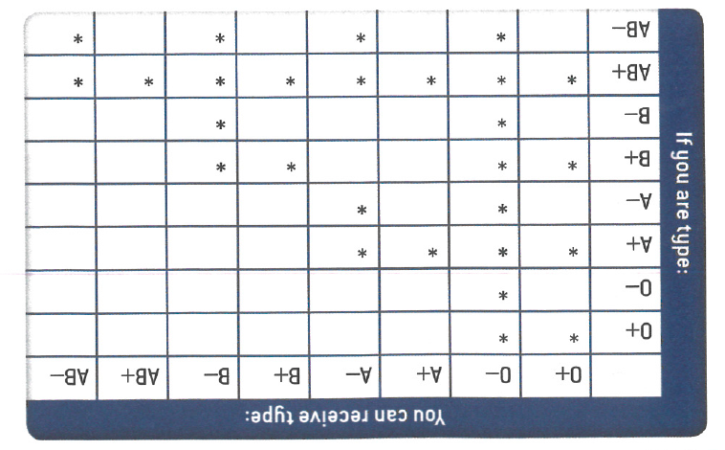

Percentage of the population of the United Stated per blood type
TOTAL POPULATION: 307 212 123
BLOOD TYPE and FACTOR | %
0+ | 37.4
A+ | 35.7
B+ | 8.5
AB+ | 3.4
0- | 6.6
A- | 6.3
B- | 1.5
AB- | 0.6

Percentage of the population of Saudi Arabia per blood type
TOTAL POPULATION: 28 686 633
BLOOD TYPE and FACTOR | %
0+ | 48.0
A+ | 24.0
B+ | 17.0
AB+ | 4.0
0- | 4.0
A- | 2.0
B- | 1.0
AB- | 0.3

Percentage of the population of Australia per blood type
TOTAL POPULATION: 22 262 641
BLOOD TYPE and FACTOR | %
0+ | 40.0
A+ | 31.0
B+ | 8.0
AB+ | 2.0
0- | 9.0
A- | 7.0
B- | 2.0
AB- | 1.0

